Dear Parents and Carers,

I do hope you are all well and still managing during this lockdown period. We are missing each and every one of you.

As we near the end of the summer term at school, as I would normally do at this time, I wanted to share with you the class and staff structure from September 2020, as I am sure you will be curious.

The Government announcements regarding schools and CoVid-19

As you will be aware, the government announced earlier this week that it was their intention that all schools in England will be open from September and ready to take all children back in full classes, as “class bubbles”. We are awaiting further guidance from the Education Minister and information around social distancing, safety of staff and children, etc. which we have been assured, will be issued over the next few weeks. At that point I hope to be able to share with you how school may operate from September when all children return. The government also announced that County Councils in England will receive funding to set up “catch up tutoring” opportunities for some children over the summer and that schools will receive additional funding to enable a recovery curriculum to support children returning to school and through out the year. I do hope to be able to share how this will work for our children over the next few weeks, but again I need to await further information, guidance and instruction from the government. As it is, I currently only have the same information that you will have received!

A growing School

Back in 2017, when I was asked to be Head of School, our pupil numbers were very low at 52 children in 2 and a half classes. I was given a brief/target to rebuild and support our school to flourish and thrive in our community once again. We have the capacity to have 120 children however we decided that 105 children would be the maximum number to work comfortably and be a viable, sustainable school moving forwards. For the last 3 years our team have worked incredibly hard, as have the PTFA and all our families (you) to rebuild our village school community, our local and national reputation, and importantly, our philosophy of education in ensuring that flourishing is for all.

I am so proud and delighted to tell you that in September 2020 we will have 93 children on roll with a further three families interested and applying over the summer. The year groupings are balanced and moving forwards, looking at our projected intake we hope to be stable at this number for a few years. Due to this we are finally able to have four classes and over the Spring term we appointed Miss Phoebe Causley as our newest member of staff. Some of you will remember that Miss Causley was with us last year in Class 2 for her second year teaching placement. She has been back to visit several times, come on school visits and naturally jumped at the chance of working with us again. We are delighted to be welcoming her to the teaching team.

Class structure from September 2020 (Covid-19 to one side!)

As some of our staff are part time, I have included the days when the teachers are working

- Class R – Reception children with Mrs Hagley (Monday – Thursday) and Miss Horrell (Fridays)
- Class 1 – Year 1 and year 2 children with Miss Causley (Monday – Thursday)
- Class 2 – Year 3 and year 4 children with Miss Budden (Monday – Friday)
- Class 3 – Year 5 and 6 children with Mrs James (Monday – Wednesday) and Miss Wotton (Thursday and Friday)
- On a Friday the structure of school is slightly different than the rest of the week. As like last year, the afternoons, from 1.15pm are organised for clubs to take place and opportunities for children to explore their talents and interests. Friday mornings will still have a core learning focus but will be taught in smaller groupings across the school, according to the age range and learning needs of the children. We will of course let you know more nearer the time. Each half term we will be having a whole school focus for learning on, for example reading, spelling and grammar, maths reasoning, number or problem solving, etc. This will give children an opportunity to experience some high impact interventions to support their learning, having not been in school over lockdown.
- All classes will have some timetabled support from our team of teaching assistants:
Mrs. Tracey Taylor, (based in Classes 1 and 2)– Deputy Safeguarding lead, mental health and wellbeing lead, pupil mentor, PSHE teacher, physical interventions across the school.
Mrs. Corinne Ashdown, (based in Class R)– First aid, Early Years Foundation Stage (EYFS), art, craft and sensory play. Phonics and spelling interventions with year 1 and across the school.
Mrs. Jenny Rodgers, (based in Class 3) qualified teacher (USA) maths specialist, dance and drama.
Mrs. Joss Chamberlain, (based in Class 2) creative writing, media and publishing, art, phonics, safeguarding, first aid.

Trainee Teachers
We believe it is important to invest in our profession and as such contribute to high quality teacher training programs in partnership with both Exeter and Plymouth Universities. Historically, we have taken student/trainee teachers at various points in their teaching degrees. This September three trainee teachers will be joining us for the majority of the academic year; One trainee teacher in classes R, 2 and 3. They will work along side the class teachers and teaching assistants. They will be working towards full time whole class lead teaching towards the end of their placements in the Summer term. This is a very exciting opportunity for all of us as trainees, staff and pupils.

Why are we a Flexi school – what does this mean?

One of the incredibly effective strategies we have used to expand the numbers of pupils we have on roll, was to embrace a radical and different approach to our school and offer this to families. Flexi schooling is used to describe a situation where a child’s parents or carers opt to educate at home for part of the time.
In 2017, Rackenford Church of England Primary School, supported by ‘The Federation of Tiverton Schools’ adopted this as a choice for parents and acknowledges that, *“Parental involvement in children’s education from an early age has a significant effect on educational achievement and continues to do so into adolescence and adulthood”. Sylva, et al (2004) Effective preschool education, Final report DFES. London: Institute of Education.

*I recognise that many of you are involved in your child’s education from an early age, especially right now in the current lockdown climate! This is not exclusively aimed at Flexi school families.

We understand that flexi schooling is not the choice for everyone, but we are so proud that we are able to be a fully inclusive school embracing all families in our community, those who wish to home school their children for part of the time and those who wish for their children to attend school full time. Flexi schooling has brought us new families both locally and from far and wide, which has had a positive impact on the rise in pupil numbers on roll. With out this rise in numbers we would be critically struggling to remain viable. Not only have we welcomed new families into our community, we have also seen a few of our full time pupils move to flexi pathways either on a short or long term basis.

Flexi school myth busting:
- Flexi schooling is agreed at the discretion of the Head of School working in conjunction with the Head of Federation and the governing body.
- Flexi schooling is not ad hoc – it is structured
- Our school budget receives the same amount of funding for our flexi children as it does for our full time children.
- Flexi schooling is a formalised partnership between school and families for the joint educational responsibilities for their children.
- Flexi families have to sign a memorandum of understanding (a contract)
- Parents/carers will provide evidence of their child’s learning journey and progress over time to support and complement the work that their child is completing at school.
- Our memorandum of understanding seeks to ensure that there is an understanding/partnership with parents so that everybody knows what is expected of them. For example, parents/carers need to know that their child is their responsibility on the days when they are not attending school.
- If school has any safeguarding or welfare concerns the flexi agreement will be revoked.
- Schools are responsible for the safeguarding and welfare of pupils, therefore it is important that school is informed if your child is ill and not attending a regular planned educational day in school.
- Flexi children attend school on a Monday, Tuesday and Wednesday with up to 2 days home education.
- Flexi schooling is not the same as ‘Compulsory School Age attendance’. Children do not have to attend school until they are 5 years old. Therefore, children not CSA may attend school on a part time basis until their fifth birthday.
- Flexi schooling is not the same as a part time timetable.
- Sometimes a child may need to be in school only on a bespoke part time basis – this is usually to meet a child’s additional or special education need and disability (SENd). This is agreed with DCC and regularly monitored.
- Flexi families cannot take additional days off or extra holidays – they have to apply for extraordinary circumstances in the same way as full time families.
- We will have 30 flexi children in September.
- When the flexi children are not in school there is a higher teacher: pupil ratio for the full time children.
- Our children are very mindful and respectful of each other; they are inclusive and understand some children come to school for three days as week, and some come to school for five days a week.
- There are no issues regarding discrimination towards both flexi and full time children/families by children or staff. This is regularly monitored.
- The education of full time children is in no way adversely effected by the attendance of our flexi children.
- Our teachers plan for teaching and learning in two “learning blocks” Monday to Wednesday and then Thursday and Friday. This ensures that our flexi children do not “miss out” or have to constantly “catch up” on work they have not done in school.
- Our research shows us that flexi children are grounded, have strong social skills and have a wide depth of knowledge, understanding and skills, furthermore, importantly they perform as well as their full time peers, making good or better progress over time.

If having spent the last three months homeschooling, this is something, which you would be interested in continuing, please do talk to us about our flexi pathways for your child’s education.

I hope that this letter has helped you start to have those conversations with your children about their classes and teachers for September. Usually we would have a few “move up days” during the Summer term but as this is not going to be possible we will be having a week of transition activities in the first week back.

Where will the classes be?
Class R (existing class 1, Mrs Hagley’s classroom)
Class 1 (existing class 2, Miss Budden’s old classroom)
Class 2 (MULA)
Class 3 (outside classroom as before)

How many children are in each class? (these may change slightly)
Class R – 21 children
Class 1 – 28 children
Class 2 – 20 children
Class 3 – 24 children

I hope you enjoy reading our pen portraits below.

With all our best wishes and kindness

Sarah and all the RPS team

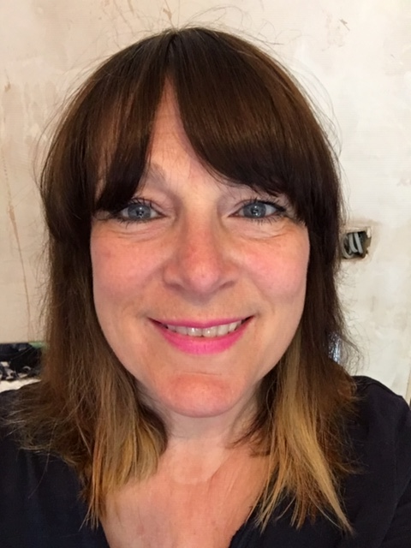 | Staff Pen Portraits  Sarah Maude  My name is Sarah Maude and I am the Head of School. I absolutely love my job and enjoy coming to work with such an amazing team, and of course with our lovely children and their families. I am very proud to be the HoS and be part of this wonderful community in such splendid Devon countryside.  I have two of my own children, Zachary and Louie who are 32 and 30 years old. Zach is a photojournalist and Louie is a writer. Zach has lived in London and Australia for the last 12 years but is coming back to live with us for a few months before moving to France. His wife, Cathy is French.
Louie finally left home last year, he used to live in a caravan in my garden! He is autistic which has been challenging for me at times but given me a real life experience of understanding autism. I live with my husband, Richard just outside Newton Abbot in a ‘self build’, that I designed myself, which is in its 6th year of being built! We are just about to lay the flooring! It is a lovely place with a little bit of land for our two dogs, chickens, fruit and veggies. Some of you have met my dogs, Ben who is a dear old Romanian shepherd and Gemma who is a Siberian husky. They take up lots of our time!

I enjoy hot sunny days and long light evenings and I love living in the Devon countryside. I practice Pilates and yoga in my studio and enjoy cooking and baking on my Rayburn. I also enjoy listening to music and watching a good old detective ‘who done it?’. I love living so close to the sea, my husband was in the RNLI for many years when we lived in Teignmouth. I cannot go a full week without dipping my feet into the water or a long walk on the seashore. I am very calm person, I like natural things and being in nature. I think of myself as a people person and problem solver not a problem maker.

Emily Budden
Hello, my name is Emily Budden and I teach Class 2. I have worked at Rackenford for 3 years now and I love it. I attended a small rural primary school very similar to Rackenford and I have many fond memories of my time there. I love learning through the outdoors and last summer I took part in Level 3 forest school training so I am always looking for ways to get outside and connected with nature. I am looking forward to hearing what you would like to learn about and resuming our learning journey together.

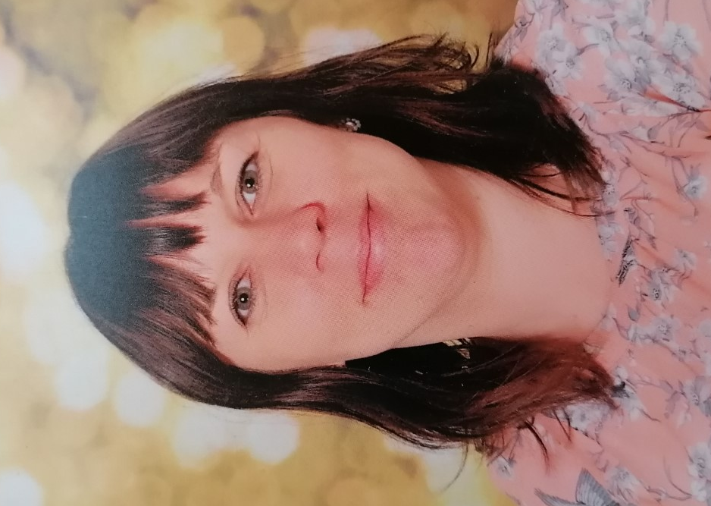 | Rachel James  Hello, my name is Mrs James and I am one of the class teachers in Class 3, which is for children in years 5 and 6. I work for 2 and a half days a week in Class 4 and I share the class with Miss Wotton, who works 2 days. We also have a lovely teaching assistant. She is called Mrs Rodgers and she is in Class 4 every day.  In September I will start my 16th year of teaching! I have taught lots of different year groups, but mostly Year 5 and Year 6.
I have also taught in lots of different places around the world, including; London, Kenya, Malawi, Egypt and Kuwait. However, I have now “returned to my roots” as they say, as I grew up in a neighbouring village to Rackenford called Witheridge and I went to Witheridge Primary school, which is very like Rackenford Primary School.

I live in Witheridge with my husband, our son and our cat Nesma, who made the long journey here from Egypt! I enjoy being outside in Nature (when it’s not raining!) I love going to the seaside, woods, rivers and moors. I also like reading and watching tv and movies.
Like most teachers, I love coffee, cake, biscuits and chocolate!! And I eat them far too much!

I am looking forward to seeing you all when we return to school and seeing both old and new faces.
Until we meet in person, enjoy your time at home, stay safe and take great care.

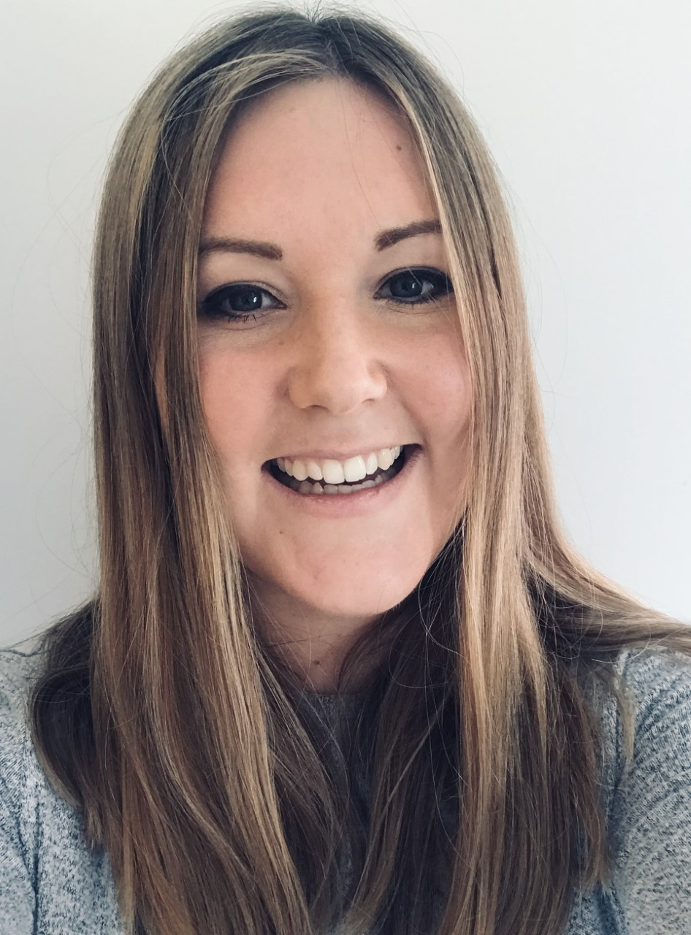 | Hannah Wotton  Hello, I’m Miss Wotton and I teach children in year five and six on a Thursday and Friday.  When I’m not working, I enjoy filling my time catching up with friends, reading, going to Zumba classes, doing small DIY projects and family trips out exploring new places. I’m really missing not seeing all the Rackenford faces and look forward to seeing you when we all return.

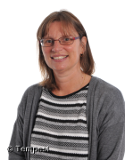 | Sharon Hagley  I have taught at Rackenford Primary School for 28 years. I have always enjoyed teaching the younger children in the school and watching them develop and flourish.  I have three children of my own and all of them came to Rackenford School. I have a little Yorkshire terrier which you might see me walking around the village.

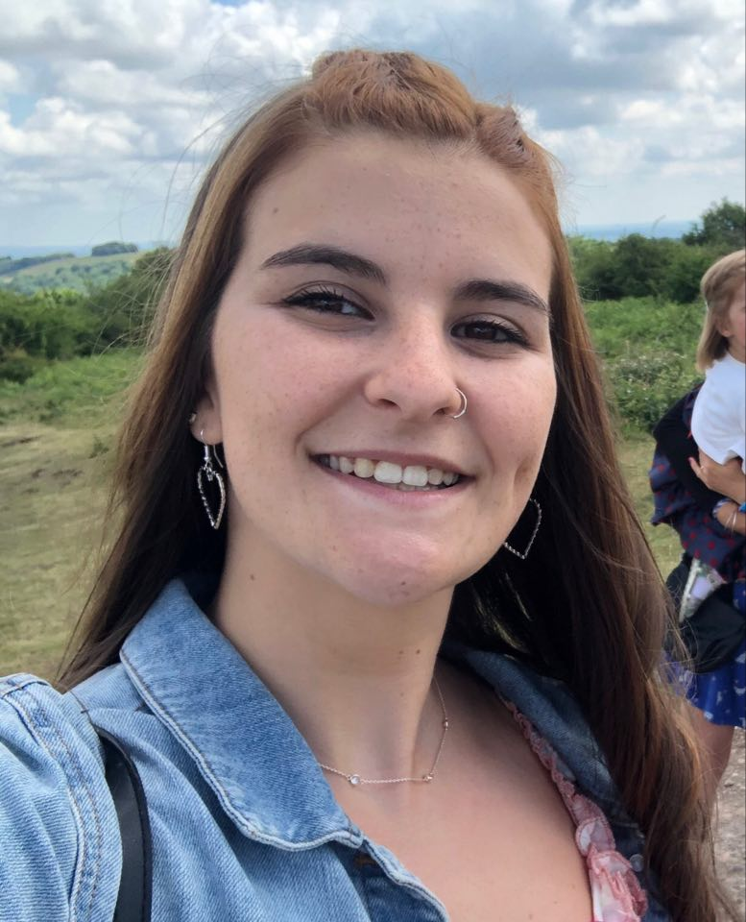 | Phoebe Causley  Hi, My name is Phoebe (Miss Causley) and I studied on a BEd Primary Education course at Plymouth University. I specialised in Maths which you will soon learn is my favourite subject and has been for longer than I can remember. I even asked for a maths party as a child! I like teaching my younger sisters Maths and trying to get them to enjoy it as much as me, and I'm hoping to do this in my class as well.  I have a big family, with 5 siblings from the age of 3 to 23 years old. I like to spend time with my family, and we go for walks on the hills and on cycle rides
for picnics in the park together! My eldest sister lives in Switzerland and I have been to visit her, and all the beautiful scenery and I can't wait to go back again!

As a child I took part in the scouting association and it has been a big part of my life growing up. I took part in a wide range of activities, competitions and camps, as well as organising activities and camps for younger scouts when helping out as a Young Leader! I took part in Scout Jamborees, fundraised and went to France, Switzerland and Germany with them and even met Bear Grylls!

I was fortunate enough to be placed at Rackenford for my second year teaching practice for part of my degree as I believe the school has great values. I was made to feel welcome by everyone from the day I started, and I have enjoyed coming back to visit and help out when possible! I'm looking forward to starting my career with my own class, with the opportunity to develop the children even further and being able to see some familiar faces again!

Mia Horrell
My name is Miss Horrell and I work in class R on a Friday. I have been teaching for over 15 years and have taught from nursery to year 6, although most of my teaching career has been in the early years and key stage one, which is where my passion lies. I have been working at Rackenford School for over 3 years on a part time basis and love my Friday’s at Rackenford School. I have a passion for working with children and helping them to meet their next steps, and I especially love teaching children to read and write and seeing the joy and pleasure on their face when they can do something new! When I am not at work, I enjoy spending time with my 8-year old twins and my dog. I am looking forward to working with lots of new faces in September.

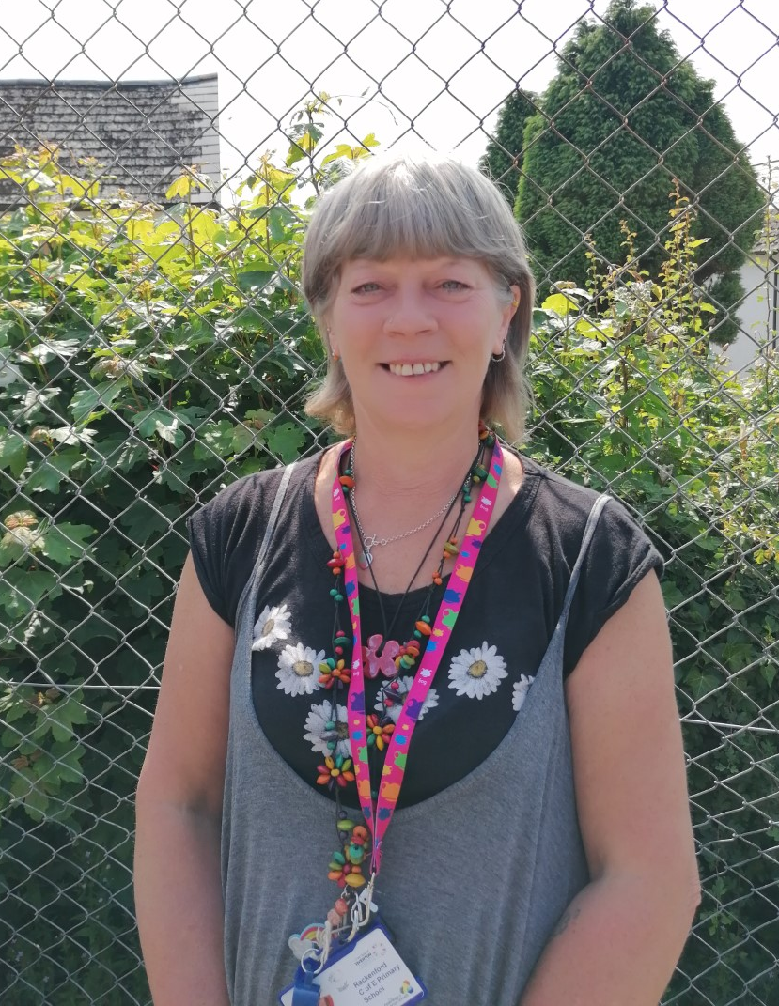 | Tracey Taylor  Hi I’m Tracey Taylor, I’ve been working at Rackenford since 2015, when I moved to Devon. I work in class 2 with Miss Budden supporting pupils with additional needs. I am deputy safeguarding lead and teach PHSE, circle time, yoga and mindfulness across the whole school. I look after pupils mental health and wellbeing and mentor pupils. I have worked in many different educational settings and find working with young people so rewarding - although not without its challenges!  I have two grown up sons. When I’m not working I’m off in my camper van with my husband and dogs. Really looking forward to seeing everyone soon!

Jenny Rodgers
My name is Jenny Rodgers and I work as a Teaching Assistant. You'll most likely find me working with Years 5 & 6, but I do also support other year groups as needed. Upon first meeting me, you'll come to realise that I am an American. My husband, daughter and I made the move to England 5 years ago and we have settled in and happily made Devon our new home. I am a trained teacher in America, with 15 years experience and absolutely love working with children - helping them to grow in confidence and develop as learners.

When I am not at school, I enjoy spending time with my family- travelling and exploring new areas. We are also currently knee-deep in a home renovation, so that keeps us very busy as well. I have missed all the children and I'm very much looking forward to getting back to our normal school-life as soon as possible.
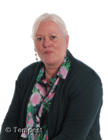 | Corinne Ashdown  I have been in education for 22 years, starting in secondary and moving to primary when I came to live in Devon. I have worked in Rackenford for 6 years now and the last two in the Reception and Year 1 class with Mrs Hagley. I love listening to the children playing and watching them form their happy relationships within our class setting, and before lock down, watching them interact with the older children around the school. I enjoy helping them develop their learning skills and watching them ‘outgrow us’, ready for their next years adventure.
I am a member of the British Beekeeping Association and keep bees myself and in my free time I love to paint. As most of the children now know, I have a love for old landrovers and enjoy off-roading and camping – I recently travelled around Ireland and Scotland. Our current project is an army landrover lightweight that I am looking forward to driving when it has been fully restored.
Kathy Perry
Hi I’m Kathy and I am a HLTA and Play Leader. I have worked at primary and secondary schools in the UK and abroad, supporting children with SEND, small groups and whole classes across all year groups. I love music, art, maths and science and love to see children enjoying creativity and scientific exploration. I am also a parent of three children, I am a long distance runner and dog groomer when I’m not in school.

Jocelyn Chamberlain
My name is Jocelyn Chamberlain (Mrs Chamberlain), I work as a Teaching Assistant at Rackenford Primary. When at University I gained a BA Honors Degree in Modern Visual Culture and Art, which was a mixture or Art history, visual theory and fine Art. However, after University I followed a career into Advertising and Marketing and completed a Professional Diploma. I then started my own family and worked part time roles, including working for an art education group. We moved to Devon in 2018 as a family, as we love the countryside and way of life. I really enjoy working at the school and providing support with the children's learning. In my spare time, I love painting, swimming in the sea and woodland walks with Emmett our dog.

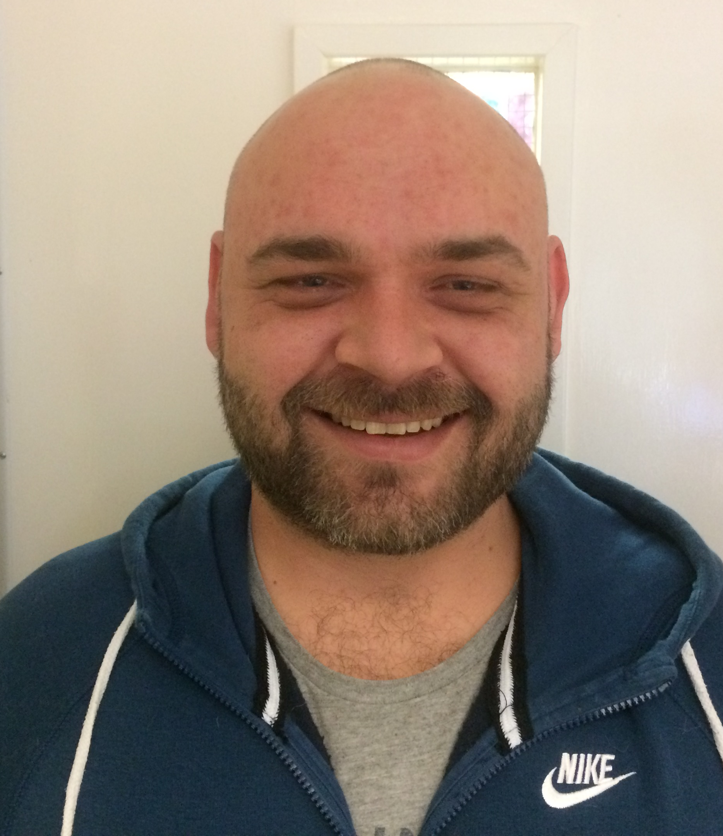 | Alan Odell  Hello my name is Alan, or if you prefer, Mr Odell. You will see me during your lunch break, I'm here to make sure you eat all the lovely school dinners and packed lunches. I've worked at the school for a few years now helping out with lunchtimes, and if you're really good maybe you can join up to do some woodwork with me and the other children, where we build planes, cars, robots....if you can dream it we can make it. Looking forward to seeing you all in the new term.

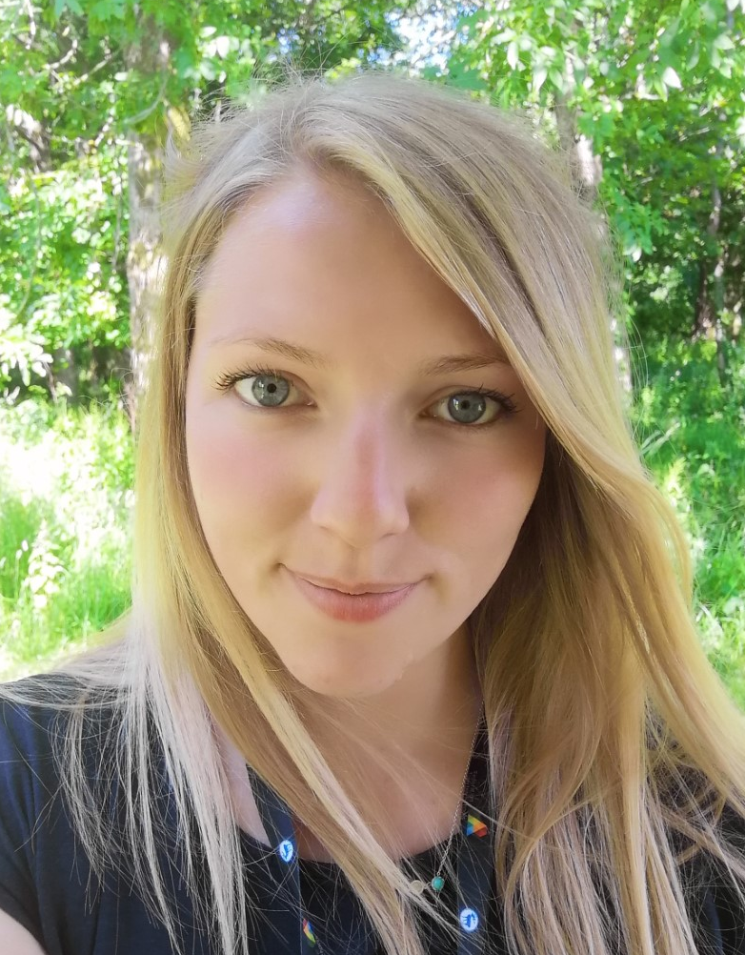 | Michaela Bundy  Hello, I’m Michaela and I have been the administrator at Rackenford Primary School for the past two years and I really enjoy it here. I really love the community feel of Rackenford, and the staff, children and their families are all so lovely.  Outside of school, I enjoy getting out and exploring the Devon countryside with my family and dog. I look forward to seeing you all when we return in September!

Jane Phillips
My name is Jane Phillips and I am the school cook. I have lived in Rackenford since 1991 and all my three children previously attended Rackenford School, as did my husband many years ago!

I enjoy my job, seeing the smiley faces and listening to what the children have been doing in school. When I am not working I enjoy riding my horse.

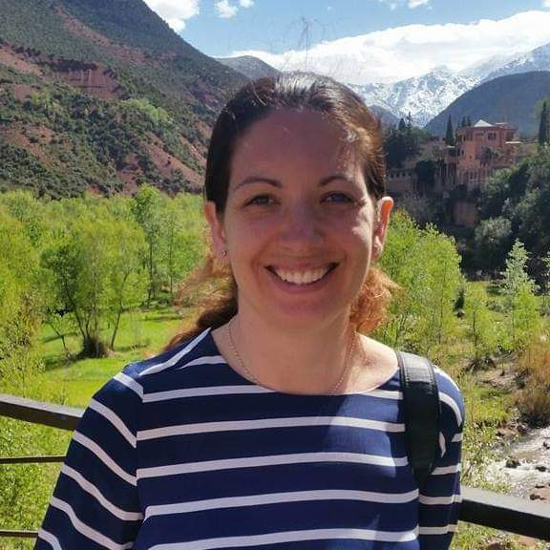 |  | Gemma Coussell  Hi my name is Gemma Coussell. Having worked in nurseries for the past 6 years as well as completing nvq's and my degree, I've taken the decision to complete my PGCE. I have 3 children of my own and have been married for 15 years to Neil. In my spare time I help out with Tiverton Town Majorettes, am an active member of the Tiverton Veterans Group and enjoying walking. I look forward to getting to know you all over the up and coming academic year.

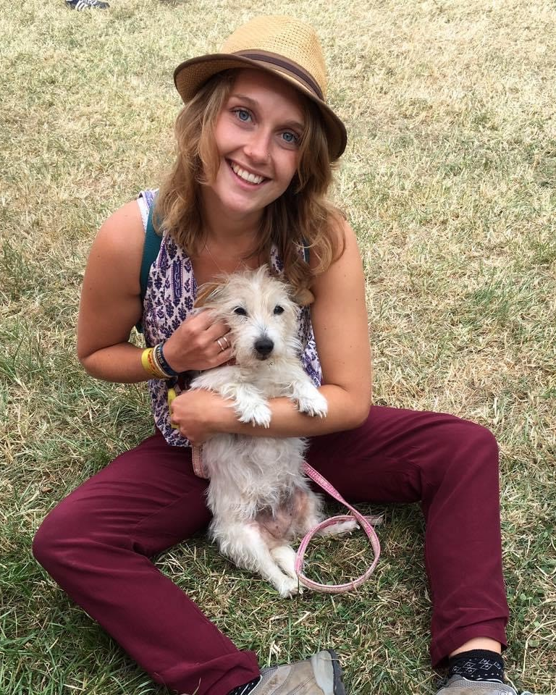 | Abigayle Mackie  Hello, my name is Abi, and I am extremely excited to be starting my PGCE teacher training at Rackenford Primary this September. I thoroughly enjoy working with children and trying to help develop their very imaginative minds! I myself am very creative and have a first class degree in printed textiles design. I like to think outside of the box and I aim to make learning both engaging and motivating for the pupils here.
Aside from being creative, I am extremely into fitness, enjoy running, and have horses that I love to compete on at a low level. I also love to travel and have recently acquired my Level 5 diploma to teach English as a Foreign Language. I hope I can make a positive difference in your children’s learning and also the warm and wonderful environment that is Rackenford Primary School.

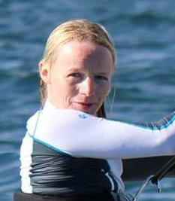 | Lucie Aldridge  I am starting the Schools Direct PGCE program in September and am very excited to be training at Rackenford. I have a degree in English and a degree in Education and feel passionate about the importance of early education in order for children to gain both confidence and enthusiasm for learning.  I love reading and the opportunities that this provides for learning about
cultures and other lives as well as a bit of escapism. I am a qualified Windsurf and Dinghy instructor and relish the opportunity to bring the skills that this has taught me into the classroom. As well as water sports I really enjoy running and yoga. I also love anything creative especially painting and sewing. I live with my husband and three children.

