14th May 2020
Dear parents and carers,
I hope that you and all your family are remaining safe and well.
We have been considering the latest update from the Government on how and when schools are going to reopen and to which year groups this will apply. The main target of the Government is that sometime from 1st June, Primary schools will reopen for Year 6 and some younger students. It has also been suggested that secondary schools should begin to prepare to ‘provide some limited face-to-face contact’ to supplement the distance learning for those students who are due to be taking public examinations next summer. For us, that would be the students who are currently in Year 10.
We are now looking in detail at how we can implement this guidance within our settings, taking into account the advice we are getting from Unions and our advisors. Although I wish for nothing more than for us to be able to return to providing a normal education, my main concern is that any provision must be as safe as possible for students, staff and families. ‘The Federation of Tiverton Schools’ has summarised this in its overall objective for this next phase: “To maximise the effectiveness of teaching and care for our students, whilst safeguarding the health and well-being of everyone on site”.
Over the coming days we will be considering if and how we can provide this face-to-face time while maintaining the protection measures expected of us during the current pandemic. In the meantime, work will continue to be provided remotely for all year groups, and we encourage all children to maintain contact with their teachers. Those continuing to access this work will be well placed when we do get back.
Please can I ask for your continued patience as I consider all the implications of the new guidelines for our three settings, in conjunction with my Heads of School and other leaders. It is an ever-evolving situation, and I will inform you of our plans as soon as possible.

I would like to reassure you that we will continue to provide the best possible education for your children while operating under the current restrictions.
Take care and stay safe
Yours sincerely
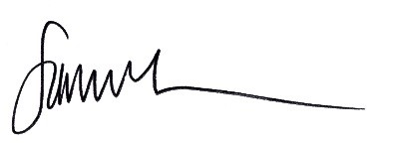
Sammy Crook
Executive Head of the Federation of Tiverton Schools

